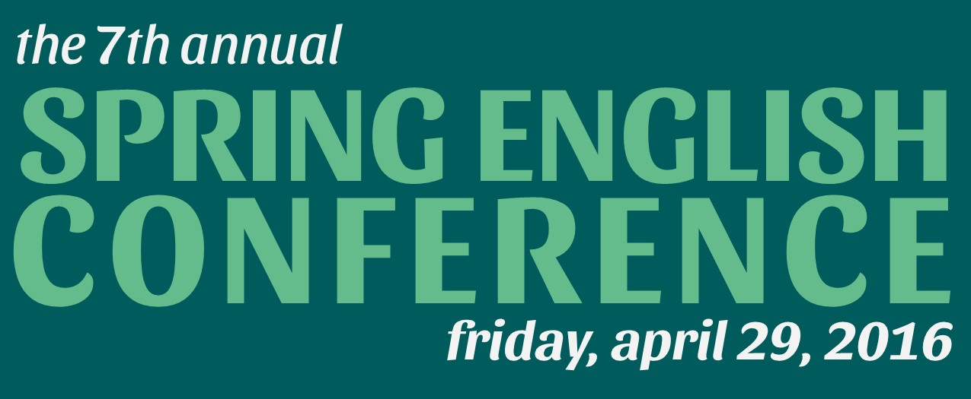

Call for Submissions – Academic and Creative Work

7th Annual Spring English Conference
Hosted by Students of the Department of English
Organizers: Anastasia Sasewich (MAWP) and Jordan Weber (MAE)
Friday, April 29, 2016 • Arts & Letters Hall 2315 N. Kenmore Ave

The DePaul English Department invites you to participate in our seventh annual student-run conference. The Spring English Conference (SPEC) will be held on the afternoon of Friday, April 29, 2016, in Arts & Letters Hall. The Spring English Conference is an annual daylong event in which undergraduate and graduate students present papers and talks as part of panels. The presentations may be in (but are not limited to) the following academic and creative areas:

Fiction
Creative Nonfiction
Poetry
Literary Analysis
Pedagogical and Literary Theory
Publishing, Professional, and Teaching Practices

The DePaul English conference is an excellent opportunity for students to showcase their work in front of a positive, supportive community of DePaul faculty and peers. If you have never publicly read your work before, consider this student-run conference. We look forward to making it a rewarding event for everyone involved!

Guidelines

1. Submit 300- to 500-word abstracts OR complete papers (complete papers are preferred, but abstracts are fine, too) for up to two works total: ONE creative piece and ONE work of literary study.
2. All submitted work, both creative and academic, should be 15–20 minutes when read aloud (approximately eight to ten double-spaced pages).
3. Please attach submissions as separate Word or .pdf files within the same email. All submissions must be emailed to englishconference.dpu@gmail.com with the subject heading “Spring Conference Submission.”
4. Do NOT put your name or any identifying information anywhere on the submission(s). Instead, enclose a cover sheet with your submissions. The cover sheet should include the following information.

Name:
Title:
Genre:
Academic program:
Phone Number:
Email:

5. If your submission is selected for the Spring Conference, you must be available to present it at a panel between 10-5pm on Friday, April 29, 2016 at Arts & Letters Hall, 2315 N. Kenmore Ave.
6. Notifications of acceptance will be sent by April 15th, 2016.
Works accepted for the conference will be grouped into panels according to genre and/or theme, and a 15-minute Q&A session will conclude each panel. All works submitted must be original, and we encourage writers to submit recent work. In the spirit of academic fellowship, we encourage participants to stay for the duration of the conference and to attend the keynote, which this year will take place mid-day, with a short reception following the speaker’s talk.

SUBMISSION DEADLINE: APRIL 1, 2016

Send submissions or any questions to englishconference.dpu@gmail.com. We look forward to reading your work!

